QSPP Compounding - NCC Affiliate Compliance Pack

Supporting documentation for affiliate pharmacies that supply NCC-compounded medicines
Document | NCC Compounding Affiliate – QSPP Compliance Pack
Version | 1.2
Issued | June 2026
Prepared by | National Custom Compounding (Managing Director)
Standard | Australian Community Pharmacy Standard AS 85000:2024 (QSPP)
Applies from | QSPP accreditation commences 1 October 2026
Review | Annually, or on change to QSPP requirements
Status of this document
This is a controlled NCC document issued to compounding affiliate pharmacies to support their transition to the Quality and Safety Pharmacy Program (QSPP). It is provided as guidance and supporting evidence; it does not transfer or remove the affiliate pharmacy’s own professional and legislative responsibilities.

Contents
QSPP Compounding - NCC Affiliate Compliance Pack 1
1. What QSPP means for your pharmacy 3
The key point – please read 3
2. How an affiliate pharmacy is assessed under QSPP 4
3. NCC Compounding Assurance Statement 5
3.1 Regulatory and quality framework 5
3.2 What NCC holds and maintains 5
3.3 Evidence NCC can provide on request 6
Attestation 6
3.4 How the NCC ordering portal supports your traceability 7
4. Roles & Responsibilities Matrix (NCC ↔ Affiliate) 8
5. QSPP clause-by-clause mapping 10
5.1 Clause 2.4 – Complex Compounding (third-party supply) 10
5.2 Clause 2.5 – Indirect Provision of Medicines 11
6. How to use this pack before your assessment 12
7. Affiliate templates (complete & hold at your pharmacy) 13
7.1 Indirect Provision of Compounded Medicines – Procedure 13
7.2 Third-Party Compounded Medicine – Risk Assessment 14
7.3 Counselling & Supply Record 15

1. What QSPP means for your pharmacy
From 1 October 2026 the Quality Care Pharmacy Program (QCPP) is replaced by the Quality and Safety Pharmacy Program (QSPP), administered by the Pharmacy Guild of Australia. QSPP accredits community pharmacies against the Australian Community Pharmacy Standard AS 85000:2024. QCPP rules continue to apply until 30 September 2026, and pharmacies with an assessment date on or after 1 October 2026 transition automatically.
Three changes matter for affiliates:
- A tiered service model. Pharmacies are assessed against the highest-complexity service they provide. Complex Compounding is the top tier (Level 4) and is assessed against demanding facility, equipment, training and quality-control criteria.
- A specific pathway for third-party compounding. QSPP expressly contemplates pharmacies that offer compounded medicines through a third party (such as NCC) rather than compounding themselves.
- A four-domain structure. The two clauses that govern the NCC affiliate relationship sit in the Delivery of Care domain: 2.4 Complex Compounding and 2.5 Indirect Provision of Medicines.

The key point – please read
Because NCC performs the compounding, your pharmacy is not a Level 4 Complex Compounding pharmacy and is not assessed against the full Level 4 facility/equipment criteria. Those obligations sit with NCC.
However, your pharmacy retains full responsibility for the safe provision of the medicine to your patient. QSPP is explicit that this responsibility is not transferred to the third party. You are assessed on whether you have: a documented third-party arrangement, a risk-assessment process, pharmacist counselling, and an indirect-supply procedure.

This pack gives you
- NCC’s assurance and evidence that the third party meets the standard, and
- the templates you must complete and hold yourself.

2. How an affiliate pharmacy is assessed under QSPP
Two clauses apply to the supply of NCC-compounded medicines. The table summarises what each requires and who is responsible.
QSPP clause | What it requires | Who holds it
2.4 Complex Compounding | The pharmacy ensures efficacy, safety and stability of compounded products. The clause includes a Note: where compounding is offered via a third party, risk assessments and counselling must occur, and the roles and responsibilities of both parties must be defined and documented. | NCC holds the facility, equipment, QC and SOP obligations.  Affiliate holds the documented arrangement, risk assessment and counselling.
2.5 Indirect Provision of Medicines | Where medicines (including compounded medicines) are provided without the patient attending in person, the pharmacy must maintain a documented indirect-supply system, conduct a risk assessment for all indirect supply, ensure pharmacist counselling still occurs, and hold a contractual agreement with the third-party addressing safety, patient data and intellectual property. | Affiliate holds the indirect-supply procedure, risk assessments, counselling records and the agreement. NCC supports compliant packaging, labelling and delivery.
Note on advertising (QSPP 2.1.3 / 2.2.5): any clinical or promotional claim your pharmacy makes about compounded medicines must be accurate, balanced, evidence-supported and compliant with the Therapeutic Goods Advertising Code. Do not represent compounded products as registered medicines or imply guaranteed outcomes.

3. NCC Compounding Assurance Statement
National Custom Compounding (NCC), trading from its purpose-built compounding facility at Suite 3-6/166 Gooding Drive, Merrimac QLD 4226, provides this statement to its affiliate pharmacies as evidence that the third party performing compounding on their behalf operates a documented, compliant quality management system.

3.1 Regulatory and quality framework
NCC’s Integrated Quality Management System (QMS Manual V2) and Quality Assurance Plan are maintained in accordance with:
- PIC/S PE 010 – Guide to Good Practices for the Preparation of Medicinal Products in Healthcare Establishments
- Pharmacy Board of Australia Guidelines on compounding of medicines
- USP <795> Non-sterile, <797> Sterile and <800> Hazardous Drugs
- Australian Pharmaceutical Formulary and Handbook (APF)
- AS 85000 (community pharmacy), ISO 14644 (cleanroom air-cleanliness classification), AS 4273 (pharmaceutical isolators) and AS 1807 (cleanroom, workstation and isolator test methods)
- Queensland Medicines and Poisons legislation and applicable WHS obligations

Where standards overlap, NCC applies the stricter control. Every compounded medicine is prepared against a valid prescription for an individual, identified patient, consistent with the extemporaneous-compounding basis on which pharmacy compounding operates in Australia (NCC does not manufacture stock for general sale). NCC is a member of the Pharmacy Guild of Australia, PCCA, the Australian Society of Compounding Pharmacists, and the Alliance of Pharmacy Compounding.

3.2 What NCC holds and maintains
The following controls are operated under NCC’s QMS and underpin the safety, efficacy and consistency of every compounded medicine supplied to your patients:
Control area | Summary of NCC system
Dedicated facility | Purpose-built ~300 m² facility with physically and mechanically separated non-sterile (Class D), hazardous/hormone, and sterile suites (Class C anteroom; Class A pharmaceutical isolators) using HEPA filtration and HVAC controls.
Equipment & environment | Calibration, maintenance and certification schedules; daily temperature/humidity monitoring via Building Management System; HEPA/hood certification by NATA-accredited providers every 12 months; HVAC servicing on a defined cycle.
Materials & suppliers | Supplier qualification and approval; receipt, quarantine and pharmacist approval of raw materials; Certificate of Analysis and SDS for all APIs; barcoded batch traceability; segregated storage of hazardous materials.
Compounding & verification | Master formulas and product files; barcode- and scale-integrated preparation records; in-process checks; independent pharmacist final review and release; lab photo capture for every preparation.
Quality control & testing | Final-product potency testing program and independent third-party potency/stability testing (time 0, 1, 3 and 6 months under normal and accelerated conditions) via NATA-accredited laboratories.
Training & competency | SOP-based training and documented competency assessment for all staff involved in compounding (not only pharmacists), with role authorisation before release duties.
Deviation, CAPA & change control | Documented deviation management, corrective/preventive action and change control under the QMS.
Complaints, adverse events & recall | Documented complaints, adverse-event and recall system with end-to-end traceability (event → patient/order → batch → materials → release → downstream supply) and recall-effectiveness checks.

3.3 Evidence NCC can provide on request
To support your QSPP assessment, NCC can supply current copies of the following as evidence that the third-party compounder meets the Complex Compounding standard. Request these from NCC ahead of your assessment date.
- NCC Quality Assurance Plan and QMS Manual (current versions)
- NCC SOP Register / Index (controlled document list)
- Facility, HEPA/hood and HVAC certification records (NATA-accredited)
- Equipment calibration and maintenance schedule and records
- Example Certificates of Analysis and supplier qualification summary
- Final-product potency / stability testing procedure and sample results
- Staff training and competency summary for compounding personnel
- Recall and adverse-event procedure
- Current professional indemnity / product liability insurance certificate
- Signed Third-Party Compounding Services Agreement (separate document)
- NCC ordering-portal order and QA-order audit trail for medicines supplied to your pharmacy (order receipt, status history, QA-order and batch linkage) – available on request to evidence end-to-end traceability

Attestation
NCC attests that the systems summarised above are documented, implemented and maintained under its Integrated QMS, and that compounded medicines are prepared, tested, labelled and released in accordance with the framework at 3.1. This statement is issued for the affiliate pharmacy named below to rely upon for QSPP assessment purposes.

______________________________
Matt Bellgrove, Managing Director Date: 24 / 06 / 2026

3.4 How the NCC ordering portal supports your traceability
Every compounded medicine NCC prepares for your patients is ordered and tracked through the NCC ordering portal. This gives your pharmacy a documented, end-to-end traceability chain – exactly the kind of evidence a QSPP assessor looks for under clauses 2.4 and 2.5.
The portal records, for each order:
- Order receipt – the prescription/order your pharmacy submits, with prescriber and patient identifiers and date/time.
- Order status history – progression through preparation, in-process checking, pharmacist verification and release, so the status of any supply can be confirmed at any time.
- QA-order and QA-template linkage – the quality record applied to that product type, batch and risk level.
- Batch and ingredient traceability – linkage from the supplied medicine back to its batch, raw materials and Certificates of Analysis.
- Preparation and release evidence – lab photo and document references and the identity of the pharmacist who released the product.

For your own records, capture the NCC order reference against each patient supply in your indirect-supply log (7.1).
If a query, complaint or recall arises, that single reference lets NCC reconstruct the full chain – order → QA order → batch → materials → release – and lets you demonstrate traceable supply for your assessment.
The underlying portal audit trail is available from NCC on request (3.3, item 11).

3.5 The NCC ordering portal in practice – communication, record-keeping and dispensing
Section 3.4 above explains the traceability chain the portal creates. This section sets out, in practical terms, how the portal is used day-to-day to support the three things a QSPP assessor focuses on under clauses 2.4 and 2.5: clear communication to the patient and the affiliate pharmacy, complete and contemporaneous record-keeping, and a controlled, pharmacist-verified path from order to dispensed medicine.

Communication to the patient
The portal carries the patient-facing information your pharmacist needs to counsel safely, and records that it was provided:
- Beyond-use date, storage and directions – the BUD, storage conditions and directions for each compounded medicine are recorded against the order, so the supplying pharmacist can communicate them accurately to the patient and document that this occurred (see the Counselling & Supply Record, 7.3).
- Supply method and patient preference – the patient’s preferred supply method (collection, post or delivery) is captured in the NCC Portal Order, so the indirect-supply pathway used for that patient is documented from the outset.
- Counselling capture – where counselling is to be delivered by your pharmacy, the portal flags this on the order and provides a place to record that it was completed, giving you the evidence QSPP 2.4 and 2.5 require that pharmacist counselling still occurred for an indirect supply.
- Product and risk information – product information and risk information for the compounded medicine are available to support that counselling conversation.

Communication to the affiliate pharmacy
The portal is the single, auditable channel between your pharmacy and NCC – it replaces email and phone trails that are hard to evidence at assessment:
- Order confirmation and status – your pharmacy sees each order progress through preparation, in-process checking, pharmacist verification and release, so you always know the current status of a patient’s supply without contacting NCC.
- Prescriber and product confirmation – the prescriber and the exact compounded product, strength and quantity are confirmed on the order before preparation, reducing transcription risk and giving both parties a shared, documented record of what was ordered.
- Affiliate identification – every order is tagged to your pharmacy, so the supply chain from your pharmacy to the patient is unambiguous and your own orders are readily filtered and reported for your records.
- Queries, complaints and recalls – the portal order reference is the shared key for any follow-up: it lets NCC investigate a product-related issue and lets your pharmacy demonstrate exactly which supply, batch and release is involved.

Record-keeping
The portal creates a contemporaneous, time-stamped record for every supply, which is precisely the documentary evidence QSPP assessors look for:
- Per-order audit trail – order receipt, status history, QA-order and QA-template linkage, batch and ingredient traceability, and preparation and release evidence (including the identity of the releasing pharmacist) are all retained against the order, as detailed in 3.4.
- Your local record – record the NCC order reference against each patient supply in your indirect-supply log (7.1) and Counselling & Supply Record (7.3). That single reference connects your local record to NCC’s full chain (order → QA order → batch → materials → release).
- Data integrity – records are captured at the point each step occurs, attributable to the person who performed it, and retained – supporting the accurate, contemporaneous and traceable record-keeping expected under the standard.
- Available on request – the underlying portal audit trail for medicines supplied to your pharmacy is available from NCC on request (3.3, item 11) to evidence end-to-end traceability at your assessment.

Integration with the RxOne dispensing system
NCC’s ordering portal is integrated with RxOne (RX-1), the pharmacy dispensing system, so that the details captured on a portal order flow into dispensing without manual re-typing – while every professional check is retained. This is a data-integrity improvement, not a removal of human oversight:
- Controlled transfer of order detail – patient, prescriber, product, strength, quantity and directions captured on the portal order are transferred into RxOne, removing the transcription errors that manual re-keying introduces.
- Scripts land for the pharmacist – transferred scripts arrive in RxOne in a deferred state for completion; nothing is finalised automatically. The dispensing act remains a deliberate, human step.
- Technician check and label – a technician checks the dispense detail against the order and prescription and prints the dispensing label.
- Pharmacist final clinical check – a pharmacist performs the final clinical check and authorises the supply. This is the legal dispensing act and it is never bypassed by the integration.
- Auditable mapping – the link between the portal order and the RxOne dispensing record is logged, extending the traceability chain through to the point of dispensing and supporting accurate dispensing records.
In short: the integration removes the re-typing, while the pharmacist and technician keep every check. The result is fewer transcription errors and a cleaner, more complete record from order through to the dispensed medicine – strengthening, not replacing, the professional controls required under QSPP 2.4 and 2.5 and the Pharmacy Board’s compounding guidelines.

4. Roles & Responsibilities Matrix (NCC ↔ Affiliate)
This matrix satisfies the QSPP 2.4 requirement that, where compounding is provided via a third party, the roles and responsibilities of both parties are defined and documented. Retain a signed copy at your pharmacy.
Activity | NCC | Affiliate pharmacy
Clinical appropriateness review at point of prescription (indication, dose, interactions) | Secondary check on formulation suitability | Primary – pharmacist review before order
Patient medication history & individual risk assessment | Supports with product information | Primary – documented per supply in NCC Portal Order
Formulation, compounding & in-process control | Primary | –
Raw material sourcing, qualification & CoA | Primary | –
Final-product QC / potency testing | Primary | –
Assigning beyond-use dates | Primary | Communicate BUD to patient
Labelling & packaging to specification | Primary (dispensing label per order) | Verify on receipt
Storage & cold chain in transit / on receipt | Compliant dispatch & packaging | Compliant receipt & storage
Pharmacist counselling of the patient | Provide product information & risks. Primary unless Affiliate chooses to be. | Primary if specified on NCC Portal Order – must occur and be recorded
Indirect-supply procedure & ordering system | Provide ordering channel & portal | Primary – documented procedure
Order placement & traceability via NCC portal | Maintain portal order, QA-order & batch audit trail | Place orders via portal; record NCC order reference locally
Recordkeeping of supply to patient | Dispensing, Compounding & batch records | Supply records through NCC Order Portal
Complaints & adverse events | Investigate product-related issues; report to affiliate | Triage, record, escalate to NCC, report as required
Product recall | Initiate & coordinate for product defects | Action recall communications to affected patients; document
Maintaining the third-party agreement & this matrix | Provide & sign | Hold, sign & present at assessment

5. QSPP clause-by-clause mapping
Maps the relevant QSPP subclauses to the NCC QMS evidence that supports them and the action your pharmacy must take. “NCC” = covered by NCC’s system (request evidence); “You” = affiliate must hold.

5.1 Clause 2.4 – Complex Compounding (third-party supply)
Subclause | Requirement (summary) | Held by / NCC QMS reference | Your action
2.2.3.1 | Trained/competent staff for all compounding personnel | NCC – Training & Competency (HR SOPs) | Keep NCC training summary on file
2.2.3.2–3.3 | SOPs, reference material, dedicated facility & cleanroom | NCC – SOP system; facility (Class C/A) | Keep NCC facility evidence on file
2.2.3.5 | Per-compound risk assessment incl. medication history | Shared – NCC formulation; you: patient history | Complete risk-assessment form (7.2)
2.2.3.6–3.7 | High-quality raw materials; safe handling/storage/disposal | NCC – Supplier & Materials control | –
2.2.3.8 | Consistency & final-product potency testing | NCC – QC & testing program | Keep NCC testing evidence on file
2.2.3.9–3.10 | Packaging, labelling, storage & beyond-use dates | NCC – Product documentation; BUD process | Communicate BUD & storage to patient
2.2.3.11 | Counselling on correct use & risks | Shared – NCC product info; you deliver | Counsel & record (7.3)
2.2.3.12 | Product recall system | NCC – Recall procedure | Action & document recalls locally
Note | Third-party roles & responsibilities documented | This pack + Agreement | Sign matrix & agreement

5.2 Clause 2.5 – Indirect Provision of Medicines
Subclause | Requirement (summary) | Held by | Your action
2.2.4.1 | Documented system for indirect provision (incl. compounded medicines): internet/post/telehealth ordering, third-party delivery, facility orders | You (NCC supports) | Adopt procedure (7.1)
2.2.4.1 | Risk assessment for all indirect supply activities | You | Complete risk-assessment form (7.2)
2.2.4.1 | Pharmacist involvement / counselling still required | You if specified in order | Counsel & record (7.3)
Note | Contractual agreement with third party addressing safety, patient data & IP | You + NCC | Execute the Agreement
Evidence | Logs of deliveries; quality monitoring & feedback | You | Maintain supply log & feedback

6. How to use this pack before your assessment

- Confirm your assessment date – the Guild will notify your new QSPP date. Anything on/after 1 Oct 2026 is assessed under QSPP.
- Request NCC’s current evidence (3.3) and file it with your QSPP records.
- Sign the Roles & Responsibilities Matrix (4) and the Third-Party Compounding Services Agreement (separate document).
- Adopt the three affiliate templates (7) – brand them to your pharmacy and embed them in your day-to-day workflow.
- Brief your pharmacists on counselling and risk-assessment expectations for compounded supplies.
- Keep advertising compliant – review any compounded-product claims against the TGA Advertising Code.

7. Affiliate templates (complete & hold at your pharmacy)
These are starter templates. Add your pharmacy name, approver and review date, and adapt to your workflow before use.

7.1 Indirect Provision of Compounded Medicines – Procedure
Purpose: To ensure compounded medicines supplied via National Custom Compounding (NCC) and provided to patients indirectly are handled safely and in line with QSPP 2.5 and 2.4.
Procedure:
- A pharmacist reviews each compounded prescription for clinical appropriateness (indication, dose, interactions, suitability) before ordering from NCC.
- A patient risk assessment is completed and documented (when submitting NCC Portal Order), including medication history and any allergies/sensitivities.
- The order is placed through the NCC ordering portal; the NCC order reference is recorded against the patient, and the patient’s preferred supply method (collection, post, delivery) is recorded inside the NCC Portal Order. The portal provides the order, QA-order and batch audit trail for this supply.
- On receipt, stock is checked against the order, inspected, and stored per the labelled conditions; cold-chain items are handled accordingly.
- A pharmacist counsels the patient on correct use, storage, beyond-use date, disposal and risks – in person or by an equivalent method for indirect supply – and records it (use 7.3).
- Supply is logged (date, product, batch where supplied, method, recipient). Feedback and any incidents are recorded and, where product-related, escalated to NCC.
- Recall communications from NCC are actioned promptly and documented.

7.2 Third-Party Compounded Medicine – Risk Assessment
Below is a series of questions that your pharmacist team could use when discussing a NCC compounded order with your patients. Alternatively, there is a digital option when submitting the Patients Order.
Field | Record
Date / Pharmacist
Patient (identifier)
Compounded product & strength
Prescriber
Clinically appropriate? (indication, dose, interactions) | □ Yes □ No – action:
Commercial product available instead? | □ No □ Yes – rationale:
Allergies / sensitivities checked | □ Yes
Medication history reviewed | □ Yes
Beyond-use date & storage communicated | □ Yes
Supply method & any indirect-supply risks
Mitigations / notes
Outcome | □ Proceed □ Refer back to prescriber □ Decline
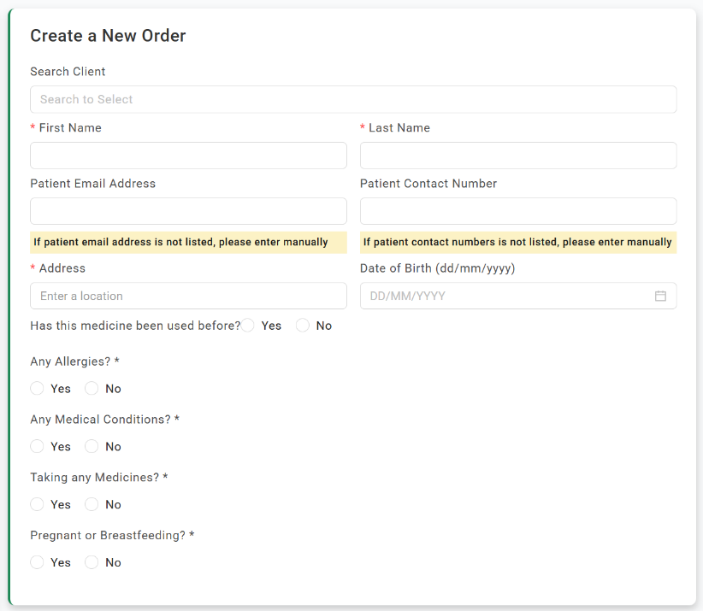

This image has been extracted from the NCC
Affiliate Order Form 24/06/2026

7.3 Counselling & Supply Record
Below is a series of questions that your pharmacist team could use when supplying a NCC compounded order with your patients. Alternatively, there is a digital option when review the Affiliate Orders page.
Field | Record
Date / pharmacist
Patient (identifier)
Product supplied & quantity
Batch / NCC order reference
Supply method | □ Collected □ Posted □ Delivered
Counselling provided on: use, storage, BUD, disposal, risks/adverse events | □ Yes – method: □ in person □ phone □ telehealth
Patient questions / issues raised
Escalated to NCC? | □ N/A □ Yes – ref:

This image has been extracted from the NCC Affiliate Order Form 24/06/2026
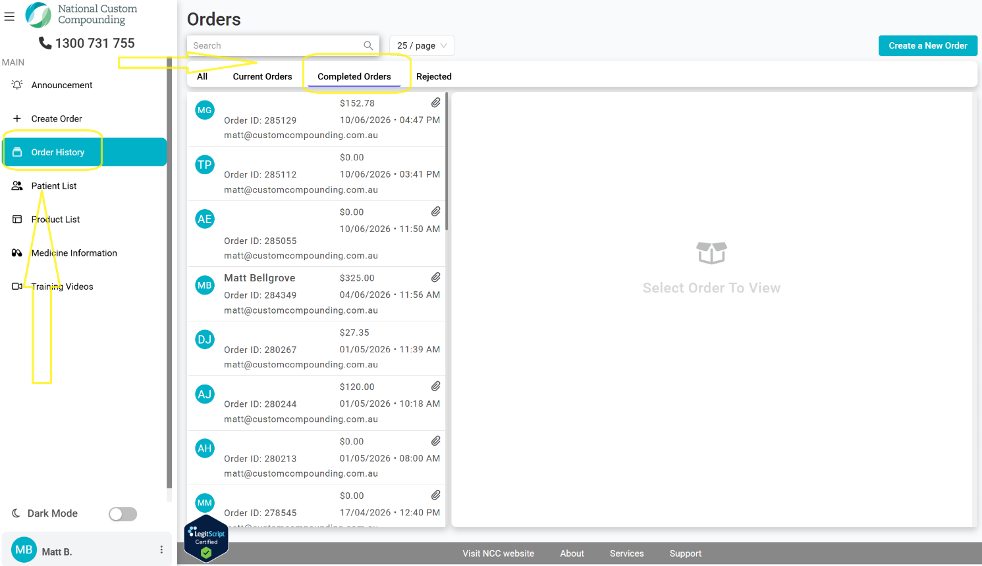

Disclaimer
This pack is provided by NCC to support affiliate pharmacies and reflects NCC’s reading of the QSPP User Assessment Guide V1.0 (March 2026) and AS 85000:2024. QSPP rules and templates may be updated by the Pharmacy Guild before 1 October 2026.
Affiliate pharmacies remain responsible for their own accreditation and should verify current requirements via the QCPP/QSPP Customer Portal. This document is not legal advice.

